

Special Educational Needs & Disability (SEND)
Information Report
& Local Offer
(To be read in conjunction with the
TPAT SEND Policy)
Roche CP School

Date Written | May 2025
Reviewed On | May 2027
Regularity | Annually
Next Review Date | May 2027
This policy has been reviewed and adopted by LGB
Date: May 2025



SEND Information Report and Local Offer
Contents
 | Page
- Introduction | 3
- Our Aims | 5
- Definitions | 6
- Roles and responsibilities | 6
- How we identify SEND | 7
- Monitoring pupil progress | 10
- Working as a team | 11
- Working with other agencies | 12
- Education Health and Care Plans | 13
- Data, Record Keeping and Confidentiality | 14
- How we support our children with SEND (Our Local Offer) | 15
- Appendix A - Services and Organisations we work with | 20
- Appendix B - Cornwall’s Local Offer | 21
- Appendix C - Useful Links | 21
- Appendix D – Glossary | 23
- Introduction
Our Local offer and Information Report read in conjunction with the TPAT SEND Policy aim to:
• Set out how Roche Primary School support and make provision for pupils with SEND
• Explain the roles and responsibilities of everyone involved in providing for pupils with SEND

This Local Offer and Information Report are based on the statutory Special Educational Needs and Disability (SEND) Code of Practice and the following legislation:
• Part 3 of the Children and Families Act 2014, which sets out schools’ responsibilities for pupils with SEN and disabilities
• The Special Educational Needs and Disability Regulations 2014, which set out schools’ responsibilities for education, health and care (EHC) plans, Special Educational Needs Coordinators (SENDCos) and the SEN information report.

Roche Community Primary School is a member of Truro and Penwith Multi Academy Trust (TPAT).
At Roche, we believe that children have a right to a safe, happy, varied and challenging learning experience. Every individual child matters and all children have abilities and potential which must be realised.
Within this context, commitment, self-responsibility, honesty and respect are the key personal qualities which we value from all members of our school community and that we feel are essential to success in later life.
We also highly value nurturing the “whole child” and do this through the school’s Five Ways to Wellbeing and Relational Approach.
We aim to meet the individual needs of all our children through quality first teaching, identifying additional needs early and offering a range of strategies and intervention programmes targeted to meet the additional needs of individuals and groups. We ensure children’s additional needs are met through the Graduated Approach, which includes the Assess, Plan, Do, Review Cycle (APDR).
We provide additional and/or different provision for the range of needs as described in the SEND Code of Practice:
- Communication and Language
- Cognition and Learning
- Social, Emotional and Mental Health
- Sensory or Physical needs.
We recognise that some of our children will have needs in more than one category.
We have excellent links with our local pre-school provisions and local secondary schools. Enhanced transition is offered to our most vulnerable pupils moving to secondary school or other provision.
Our highly motivated teachers and support staff have a high level of experience and training relating to a wide range of SEND. Training is ongoing and relevant to current and anticipated need.
We work closely with a wide range of outside agencies to ensure that every child has the opportunity to learn and make progress.
Our school environment (internal and external) and school routines, such as lunchtimes and break times, have been carefully designed to improve pupils’ relationships and wellbeing. They are designed with adaptability and accessibility in mind to ensure we provide a welcoming place for all learners.
We have an excellent EYFS outdoor environment as well as a wider meadow area and extensive field and playground.
We also have wraparound care from 8am to 6pm as well as a wide variety of clubs and extra-curricular activities after school. We work with parents to ensure that children with SEND have access to a range of opportunities for personal development, for example, through a variety of clubs and school trips and residentials. We provide 1:1 support if necessary at after school clubs to ensure all our SEND pupils can take part.
We have strong community links as well as working in close partnership with other schools in the Truro and Penwith School Trust.
We believe that it requires a whole team to help those with SEND. Parents/carers are a hugely important part of this team. They know their children best and are often experts on any disabilities, illnesses or needs their child may have. We will always endeavour to include parents and value their input, in discussion and planning of provision for their child’s needs.

- Our Aims
Through our local offer we aim to:
- Provide a balanced and broad curriculum that promotes the spiritual, moral, cultural, emotional, academic and physical development of pupils.
- Promote a healthy lifestyle and prepare them for the opportunities, responsibilities and experiences of adult life.
- Give access to the National Curriculum and, for those pupils with general and specific learning difficulties effective and personalised programmes.
- Enable pupils to improve their behaviour to a socially accepted level and offer effective and appropriate support for their emotional development.
- Respect all pupils and encourage them to become active participants in their own learning, develop confidence, independence, self-esteem and express their needs and desires.
- Seek effective links with pupils’ families, schools and other professional agencies.
- Seek effective outcomes with transition from home and partner nurseries and also to secondary school as well as to and from other primary schools
- Develop a community of learners working to realise their potential and we are committed to raising aspirations for all.
- Develop communication and self-help skills. Our teachers and teaching assistants are all experienced in delivering learning for pupils with special educational needs.
Staff are committed to identifying and providing for the needs of all pupils, in an inclusive environment where pupil abilities are supported and valued. Staff seek to overcome barriers to learning and are committed to ensuring that special educational needs are catered for in every areas of the curriculum so pupils can achieve positive outcomes.
Roche Primary School has high expectations of respect and kindness towards each other, using rewards as positive reinforcement and with a view to learning from our mistakes as well as restorative conversations. See also Behaviour Policy.

3. Definitions
See Truro and Penwith Academy Trust SEND Policy.
4. Roles and Responsibilities
4.1 SENDCo

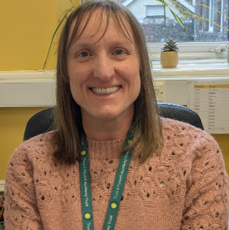

Our SENDCo is: Claire Powell. She is a qualified teacher with over 18 years of experience and is currently undertaking the National SENDCo qualification.
sendco@roche.tpacademytrust.org
The role and responsibilities of our SENDCos are set out in the TPAT SEND Policy.
4.2 Local Monitoring Committee – SEND


Our Local Monitoring Committee member (formally governor) for SEND is Tina Leack.
You can contact her on reception@roche.tpacademytrust.org
The role and responsibilities of our Local Monitoring Committee are set out in the TPAT SEND Policy.
4.3 Headteacher

Our Headteacher is Jeremy Walden
jwalden@roche.tpacademytrust.org
The role and responsibilities of our Headteacher are set out in the TPAT SEND Policy.
4.4 Teachers
The role and responsibilities of our teachers are set out in the TPAT SEND Policy.
We recognise that there needs to be a whole team around the child with SEND. Those involved may differ according to individual need, but will always include the child, their parent/carer, teacher, SENDCo, headteacher and relevant others.
4.5 Teaching Assistants (TAs)
We have a team of TAs who work under the guidance of teachers and are trained in certain areas.
Some TAs are trained to provide additional interventions such as lego therapy, We Thinkers, Precision teaching, maths and literacy catch up.
5. How we identify SEND

If you think your child might have SEN, the first person you should tell is your child’s teacher. You can do this each evening at the school gate or call into the office.

They will pass the message on to our SENDCO, Claire Powell, who will be in touch to discuss your concerns.
You can also contact the SENDCO directly, see above.

We will meet with you to discuss your concerns and try to get a better understanding of what your child’s strengths and difficulties are.
Together we will decide what outcomes to seek for your child and agree on next steps.
If we decide that your child needs SEN support, we will formally notify you and your child will be added to the school’s SEND register.

Early identification is vital.

Teachers, parents and the pupils themselves highlight any difficulties with pupils’ learning and these are discussed with the SENDCo. Information may also be received from a previous school or setting.
When a concern has been raised, the SENDCo may then advise, or observe
in the class and then advise the teacher on strategies/interventions. The pupil will be closely monitored to see if advice followed has closed any gaps.

If progress is not made quickly enough, then the school will place the pupil on our SEND register and have a conversation with the parent/carer to inform them of this.

Every school must keep a register of pupils with SEND and it helps ensure provision is made well for those pupils. At Roche, we are committed to ensuring that all learners have access to learning opportunities, and for those who are at risk of not learning, we will work with them to try and rectify this situation; identifying and helping with the underlying cause where at all possible.

The flow chart below shows the process of SEND Support.
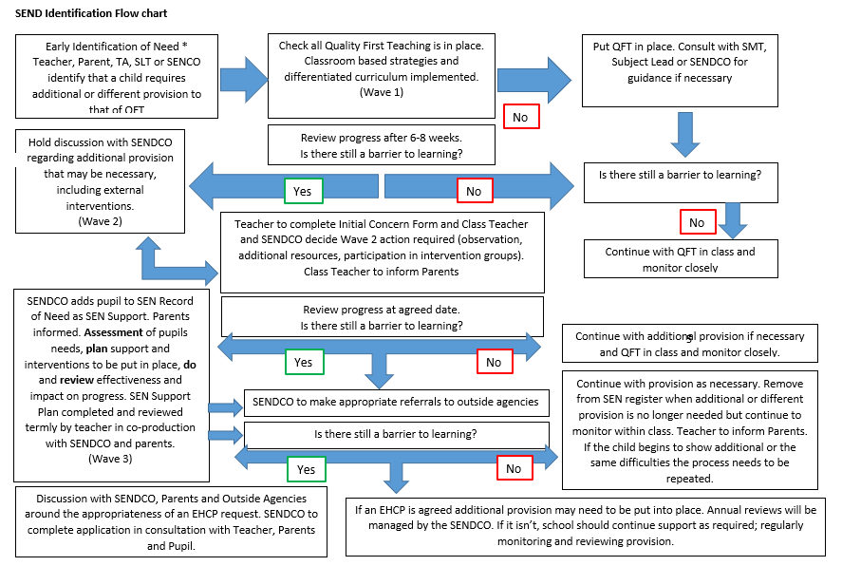
At Roche CP School, we ensure that the assessment of educational needs directly involves the learner, their parents/carer and their teacher. The SENDCo will also support with the identification of barriers to learning. For some learners we may want to seek advice from specialist teams.

6. Monitoring pupil progress
Monitoring progress is an integral part of teaching and learning within the school.
There is regular assessment within lessons, and progress and attainment data is gathered half-termly. This is analysed by both classroom staff, Senior Management Team and SENDCo. The SENDCo also reviews the progress of all pupils with SEND to ensure they are making the expected or better progress. Where this is not the case, the SENDCo will liaise with the teacher, pupil and parents and discuss what the issues are and what action could be taken. The SENDCo is then involved in supporting teachers drawing up APDR plans for children.
The SENDCo and the Headteacher hold regular meetings to review the work of the school in this area.
The SENDCo and the named LMC member with responsibility for special needs also hold termly meetings.
This support will follow the ‘assess, plan, do, review’ model and the impact of the intervention measured. This cycle is summarised below
Once a child is placed on SEND Support they enter a system of APDR (Assess, Plan, Do, Review). Please see TPAT SEND Policy.
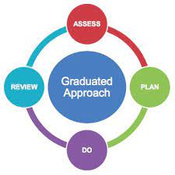
Teachers and Parents work together to develop targets and strategies to help the child. Review meetings are at least termly.
If relevant, the teacher or SENDCo will consult with parents about seeking advice from internal (TPAT) and external support services.
This could be if a pupil:
- continues to make little or no progress in specific areas over a long period,
- continues working at National Curriculum levels substantially below that expected of children of a similar age,
- continues to have difficulty in developing literacy and mathematical skills,
- has emotional or behavioural difficulties which substantially and regularly interfere with the child’s own learning or that of the class group, despite having an individualised behaviour management programme.
- has sensory or physical needs, and requires specialist equipment or regular advice or visits by a specialist service,
- has an ongoing communication or interaction difficulty that impedes the development of social relationships and cause substantial barriers to learning.
The graduated response using an Assess, Plan, Do, Review strategy employs a small-steps approach ensuring pupils have targets to meet their personal needs. By breaking down the existing levels of attainment into finely graded steps and targets, we ensure that children experience success. All children on an EHC plan or SEN record of need have an APDR plan.
Effective planning helps parents, children and young people with SEND express their needs, wishes and goals.

- Working as a team
The staff at Roche school work closely with parents and pupils. They value their views and involve them fully in reviewing provision to ensure the pupil’s progress and success.
7.1 Partnership with parents and carers
The school works closely with parents and carers in the support of their children with special educational needs. We encourage an active partnership through an ongoing dialogue with parents and carers. Communication is central to this. Parents and carers have much to contribute to our support for children with special educational needs. As such we have, for example:
- home/school books
- Regular meetings and phone conversations

- APDR meetings termly where parents are asked for their input.
- Yearly Parent Voice survey
- Meet and greets daily with child and parent where needed.
The school website contains details of our policy and Information Report for special educational needs, and the arrangements made for these children in our school. A named Local Monitoring Committee member takes a particular interest in special needs and is always willing to talk to parents and carers.
At the regular termly meetings with parents, progress and targets of special needs children are shared and discussed with their parents or carers. We consult with the parents/carers regarding any outside intervention, and we share the process of decision-making by providing clear information relating to the education of children with special educational needs. We hold regular meetings with Teachers, TAs, SENDCo, SEN LMC member and Headteacher to review and update the progress of pupils with SEND.

7.2 Partnership with pupils
In our school, we encourage children to take responsibility and to make decisions. This is part of the culture of our school and relates to children of all ages. The work in the Early Years Foundation Stage recognises the importance of children developing social as well as educational skills.
Children are involved at an appropriate level in setting targets in their APDRs and in the termly review meetings. These targets are shared and reviewed in the form of ‘Catch Me cards’ on which both adults and pupils can record and monitor their progress. Children are encouraged to make judgements about their own performance against these targets. We recognise success here as we do in any other aspect of school life
We may seek your child’s views by asking them to:
Attend meetings to discuss their progress and outcomes
Prepare a written statement, video or drawing, etc.
Discuss their views with a member of staff
Complete a survey.

Working with Internal (TPAT) and external support agencies

If required, the school will ask for support from the inclusion team within the Trust and can also refer to external agencies such as:
Speech and language therapists
Educational psychologists
Occupational therapists
GPs or paediatricians
School nurses
Child and adolescent mental health services (CAMHS)
Education welfare officers
Social services and other local authority (LA)-provided support services
Voluntary sector organisations
Local Authority SEND Support Teams.
See Appendix A.

- Education, Health & Care Plans
9.1 Assessment

Where a pupil’s needs cannot be met through SEN Support school resources, the school will, in consultation with the pupil’s parents, request an EHC needs assessment. If the decision is taken by the LA not to issue an EHC plan, the school will consider and implement the recommendations of feedback from the local authority, regarding how the pupil’s outcomes can be met through the school’s existing provision. This process takes 20 weeks. More details can be seen here: Request an Education, Health and Care Plan needs assessment - Cornwall Council

9.2 Named school

If Roche Primary school is consulted by the authority regarding being a named school on an EHCP we will respond to the consultation. If Roche Primary School is named on a pupil’s EHC plan we will admit the pupil and ensure that all those teaching or working with the pupil, are aware of their needs and that arrangements are in place in to meet them. The school will request a re-assessment of an EHC plan at least 6 months following an initial assessment, if a pupil’s need significantly change.

9.3 Reviewing an EHC plan
Roche CP School will:
- Ensure annual reviews take place at least annually and sooner if required. This includes convening the meeting on behalf of the local authority if requested (interim APDR meetings will also take place between annual reviews).
- Ensure that appropriate arrangements are put in place at the school to host the annual review meeting.
- Seek advice and information about the pupil prior to the annual review meeting from all parties invited.
- Send any advice and information gathered to all those invited at least two weeks prior to the annual review meeting.
- Cooperate with the local authority during annual reviews.
- Prepare and send a report of the meeting to everyone invited within 2 weeks of the meeting.
- Ensure that a review of a pupil’s EHC plan is undertaken at least 7 months before transfer to another phase of education.
- Targets from the EHCP will be used to inform the termly APDR (Assess, Plan, Do, Review) process.

- Data, Record Keeping and Confidentiality
Data and record keeping
The school will include details of SEND outcomes, teaching strategies and the involvement of specialists, as part of its standard system to monitor the progress, development of all pupils.
The school uses a confidential online tool called Insight to record and share all SEND data. It is interactive so records can be updated quickly. For example. When children reach outcomes set out in their Learning Plan it can be recorded immediately.

11. The levels of support and provision offered by Roche Primary School - our Local Offer

The support and provision Roche school makes for children with SEND can be found below.
1 – This is support and provision that is available to the whole school.
2 – This is support to those who need some additional help. This may be targeted for a particular need and is often time limited.
3 – This is specialist or individual support for pupils with high or particular need.

Appendix A
Services and organisations that we work with

Service/organisation | What they do in brief
Child Health Department | Community paediatricians, physiotherapists, occupational therapists (OTs), speech and language therapists, emotional and mental health practitioners and other health professionals work with children with individual needs
Educational Psychology | Specialists in learning, behaviour and child development
SEN Support Services | Teams cover Autism, Educational Psychology, Moving and Handling, Augmented and Additional Communication, Cognition and Learning, Speech and Language, Hearing, Physical and Medical needs, Vision
Speech and Language Therapy (NHS) | Advice and support for all speech and language and communication needs
Child and Adolescent Mental Health Service (CAMHS) | Support children and adolescents with a wide range of emotional, mental health and behavioural issues
Penhaligon’s Friends | Support and programmes to help bereaved children and their families
Dreadnought | Support and programmes to help children with behavioural and emotional difficulties
Early Help Hub | Single point of contact and co-ordination service for disabled children
Educational Welfare Service | Promote children’s regular school attendance
School Nurse Team | Providing community health services and support to schools, children and their families
Multi Agency Referral Unit (MARU) | Provide advice and multi-disciplinary response to concerns about safety
Statutory Special Educational Needs Service | The Statutory Special Educational Needs (SEN) Service is responsible for: The Education, Health and Care (EHC) needs assessment processes and the maintenance and review of existing EHC plans The team work with, education settings families a range of services and other local authorities.
Sendiass (Special Educational needs and Disability Information and Advice Service) | Provide information and support for parents and carers of children with individual needs
Family Information Service | Provides impartial guidance on local services and support available to families

Appendix B
Cornwall’s Local Offer
Cornwall’s ‘Local Offer’ can be found here:

https://www.cornwall.gov.uk/education-and-learning/schools-and-colleges/special-educational-needs-file/cornwall-send-local-offer/

What's included in the Local Offer?
Cornwall’s SEND Local Offer includes the provision and guidance that is available for children and young people:
- who are aged 0 – 25 years; and those
- with or without an Education, Health and Care (EHC) plan or Statement of SEN
Please see this list of things that are included in the SEND Local Offer and quick links to the relevant part of the site.
Appendix C
Links to helpful websites:
National SEND Data
Special educational needs in England, Academic year 2024/25 - Explore education statistics - GOV.UK
Special Needs Jungle: https://www.specialneedsjungle.com/
SEN SOS! : https://www.sossen.org.uk/
Cornwall Accessible Activities Programme: https://www.caapuk.co.uk/
Parent Carers Cornwall: http://parentcarercouncilcornwall.org.uk/
Neurodiversity Hub: https://parentcarerscornwall.org.uk/neurodiversity/
National Autistic Society: https://www.autism.org.uk/
PDA Society: https://www.pdasociety.org.uk/
Dyslexia Cornwall: https://www.dyslexiacornwall.org.uk/
Speech and Language Development: https://ican.org.uk/i-cans-talking-point/
Contact, for families with disabled children: Contact: the charity for families with disabled children
Young Epilepsy: https://www.youngepilepsy.org.uk/
Sensory Processing Disorder: www.spdstar.org

Appendix D Glossary
APDR | Assess, Plan, Do, Review | SALT | Speech and Language Therapy/Therapist
CAAP | Cornwall Accessible Activities Programme | SEND | Special Educational Needsand Disability
CAMHS | Childrens and Adolescent Mental Health Service | SENDCo | Special Educational Needs and Disability Coordinator
EP | Educational Psychologist | SENDIASS | Special Educational needs and Disability Information and Advice Service
EHCP | Education, Health and Care Plan | TA | Teaching Assistant
EYFS | Early Years Foundation Stage | TAC | Team Around the Child
FIS | Family Information Service | Thrive | A system to help pupils with emotional difficulties.
KS | Key Stage | TiS | Trauma Informed Schools
Meta-  cognition | The process by which children plan, monitor, and reflect on their own learning, This process also helps them to decide on the tools they need to complete a task. | Transition | Any change in schooling, from nursery to school, between years, key stages or schools.
OT | Occupational Therapist | Zones of Regulation | A system to help children emotionally regulate
PSHE | Personal Social and Health Education
Information Report status and review

Written by: | Claire Powell
Status: | SENDCo
Approval date: | Oct 2025
Review Date: | May 2027

